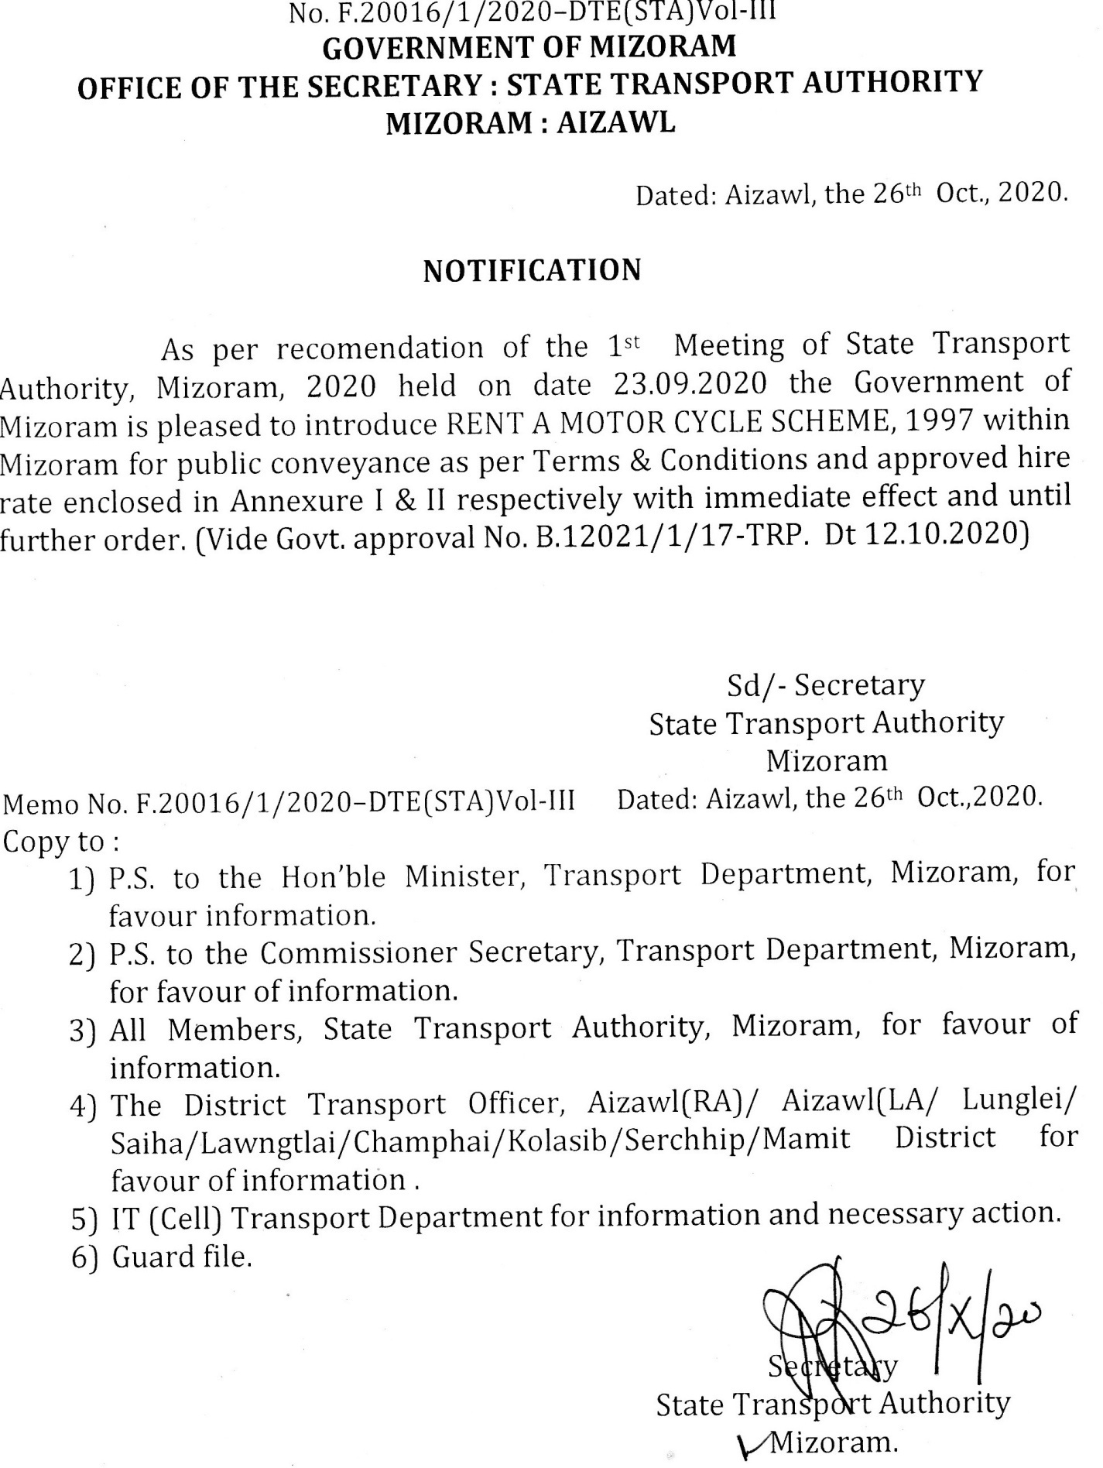

ANNEXURE - I
TERMS AND CONDITIONS
FOR
RENT A MOTOR CYCLE SCHEME, 1997
1. Rent a Motor Cycle Scheme hi Contract Carriage permit hnuaiah dah a nih angin Operator Licence nei lo chuan he Scheme hnuaiah hian sumdawnna a ti ve tur a ni lo.{Sec. 74(1)of MV Act, 1988}
2 Operator Licence dilna form siamsa Form-1 hmangin dil tur a ni.(Enclo:Form 1)
3. Operator Licence pek a nih dawn chuan he dan provision No. 5 point (i) to (iv) hi diltuin a zawm hmasa ngei tur a ni. ( Enclo: Provision No. 5)
4. Operator Licence hmutu chuan he scheme provision No. 8 clause (i) to (viii) te hi tha takin a zawm tur a ni. ( Enclo: Provision No. 8)
5. Operator-in Two Wheeler ( 110cc aia hniam lo) ama hmingin 5 (Panga) aia tlem lo a nei tur a ni.
6. Operator Licence hi kum 5 atan pek a ni ang a: Licence hi a tul angin renew theih a ni ang.
7. He Scheme provision No. 11 (1) hmangin Licencing Authority(STA)-in Licence cancel-sak/suspend emaw fine-tir theih a ni. {Enclo : Provision No. 11(1)}
8. He scheme hnuaia operator-te hremna pek an niha lungawi lohna an nei a nih chuan, order chhuah atanga ni 30(Sawmthum) chhungin thuneitute hnenah lungawi lohna thlen theih a ni.
9. Operator Licence neituin eng hunah pawh a licence chu tax leh fee te pe fel vekin a surrender thei ang. Hei hi thu neituin a cancel nghal bawk tur a ni (Provision no. 14)
10. Operator Licence fee hi Rs 1000/- a ni.
11. Rent a Motor Cycle Scheme 1997 hnuaiah hian motor brand new emaw kum khat aia upa lo chauh register theih a ni ang.
12. Rent a Motor Cycle Scheme 1997 hnuaia motor registration plate chu a background dum (Black)-ah a eng(Yellow)-a ziah tur a ni.
13. Operator hnuaia motor-te hi Mizorama register ngei a ni tur a ni. Motor register belh duh a nih pawhin operator hminga motor awm chauh, STA atanga phalna la hmasain register belh theih a ni ang .
14. Sorkarin rate a siam ang chauhin motor hire-tir tur a ni.
15. Operator ten valid driving licence neite chauh motor an hire-tir tur a ni a; hire- tu hming leh nihna kimchang tha takin an record vek tur a ni.
16 Office hmun sawn dawnin emaw Branch Office hawn dawnin thuneitu/ Licence pe chhuaktu hnenah phalna lak hmasak tur a ni.

RENT A MOTOR CYCLE SCHEME, 1997

PROVISION N0. 5
A licencing authority shall, before granting or renewing a licence take into considedration the following, namely :-
(i) That the applicant has a good moral cherecter an has intimate knowledge of passenger transport business.
(ii) That the applicant has necessary facilities for the housing, maintenance and repair of his vehicles, sanitary block and reception room.
(iii) That the applicant has at least one telephone which is accessible throughout day and night.
(iv) That the financial resources of the applicant are sufficient to provide for the continued maintenance of motor cycle and for the efficient management of the establishment.
(v) That the applicant maintains not less than 5 motor cycles duly covered by permits issued under sub- section(1) of section 74 of the Act, with comprrehensive insurance, fitness certificate, motor vehicle tax upto date.

RENT A MOTOR CYCLE SCHEME, 1997
PROVISION No. 8
General condithons to be observed by the holder of the licence. – The holder of the licence shall, -
- maintain a register with a separate page for each vehicle containing the particulars specified in form 3 and where motor cycle is hired by a foreign national, shall maintain a register in form 4;
- not shift the principal place place of business mentioned in the licence without the prior approval in writing of the licensing authority which granted the licence.
- keep the premises and all the records and registered maintained and the motor cycles open for inspection at all resonable times by the licensing authority or by any person not below the rank mof motor vehicle inapector as may be authorized in this behalf by the licensing authority;
- submit from time to time, to the licensing authority such information and return as may be called for by it;
- display at prominent place in its mai office and its branch office, the licence issued in original and certificate copies thereof, attested by the licensing authority;
- maintain their main office and branch office at a conpicuous place a “Complaint Book” in the form with serially nunberedpages in triplicate. The licensee shall despatch the duplicate copy of complaint, if any, to the licensing authority by registered post expeditiously in any case not later than 3 days;
- Maintain a suggestion box in the main office and branch offices and forward their suggestion received with their comments, if any, to the licensing authority once a month.

ANNEXURE – II

APPROVED HIRE RATE OF MOTOR CYCLE
UNDER RENT A MOTOR CYCLE SCHEME, 1997
Sl. No. | CONDITIONS | AMOUNT | REMARKS
1 | Per hour (or less) | Rs. 60/- | Without fuel
2 | Whole day (6:00 am – 6:00 pm) (or less) | Rs. 600/- | Without fuel
3 | Whole day & night | Rs. 1000/- | Without fuel

NOTE : Operator-in fuel thunna hnai ber thlen theihna tur a motorah fuel a dahsa emaw ama stock atangin man chawiin fuel a thunsak ang.

