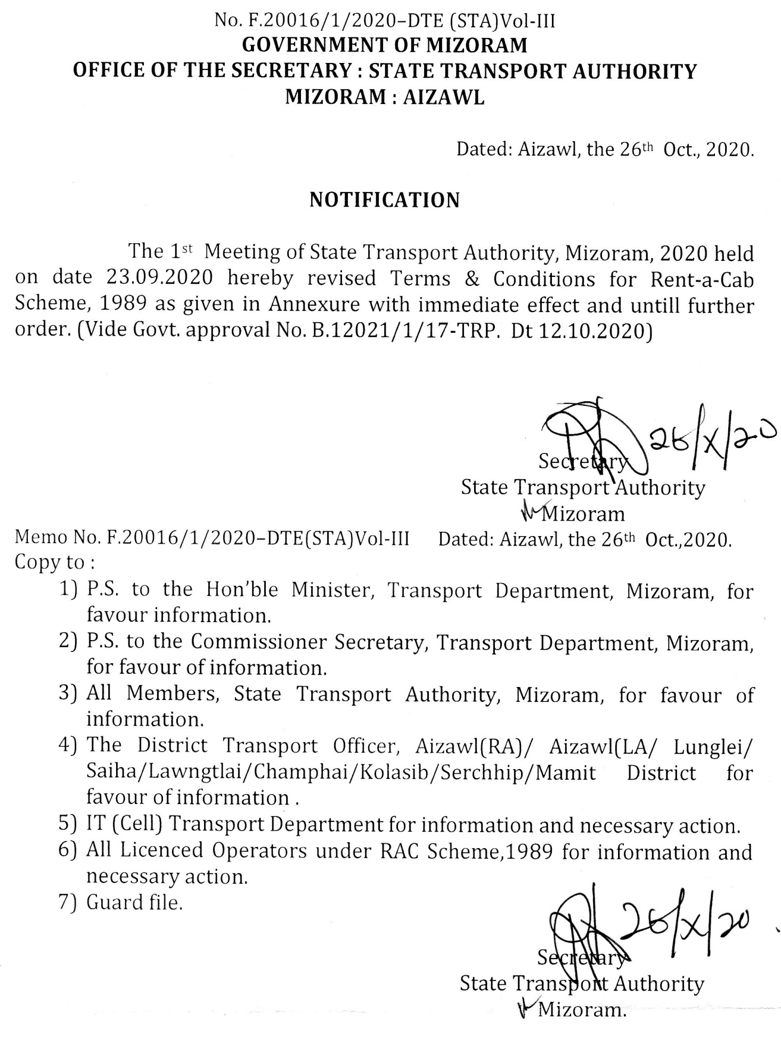

ANNEXURE

TERMS AND CONDITIONS
FOR
RENT A CAB SCHEME, 1989

1. Operator Licence diltu chuan ama hmingin motor 25 aia tlem lo a nei tur a ni .
2. Form 5 & 6 -a mi angin Register vawn that tur a ni (Form 5&6 enclosed)
3. Office hmunhma leh register–te felfai taka vawn tur a ni a. Motor pawh englai pawha enfiah ngamin a awm tur a ni. MVI chin chunglam emaw endik tura ruat bikten an endik thei ang.
4. Office hmun sawn dawnin emaw Branch Office hawn dawnin thuneitu/Licence pe chhuaktu hnenah phalna lak hmasak tur a ni.
5. Office-ah Suggestion box dah tur a ni a, chutiang lehkha a awm chuan Licencing Authority hnenah theh luh tur a ni.
6. Rs. 5000/- deposit nghal tur a ni. Engtik lai pawhin thuneituten an enfiah thei ang. Dan zawm a nih loh chuan eng hunah pawh Operator Licence hi tihtawp theih a ni ang.
7. Operator hnuaia motor-te hi Mizorama register ngei a ni tur a ni. Motor register belh duh a nih pawhin operator hminga motor awm chauh, STA atanga phalna la hmasain register belh theih a ni ang .
8. Rent-a-Cab Scheme, 1989 hnuaia motor register-te chu Transport vehicle an ni a, state danga an kal dawn chuan special permit an la thin tur a ni. (Rule 95 of MMVR, 1996)
9. Motor hlui 8 years aia upa hman phal a ni lo.
-------x-------

