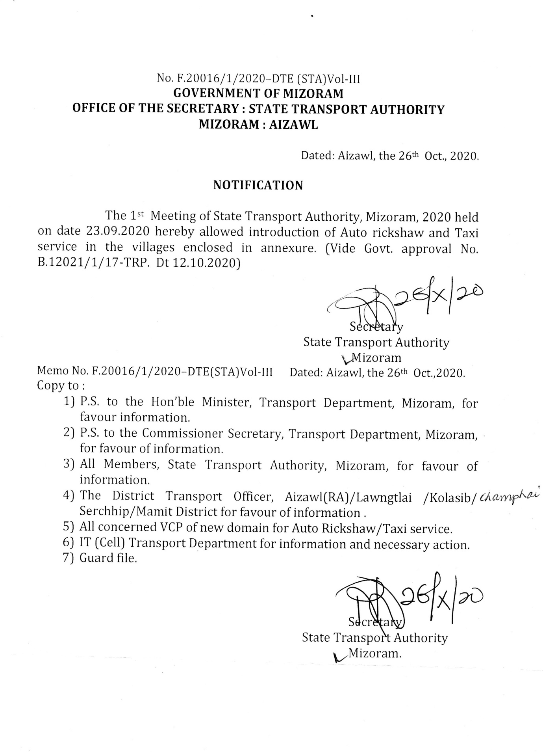

ANNEXURE
- NEW DOMAIN FOR AUTO RICKSHAW SERVICE
Sl. No. | DOMAIN | DISTRICT
1 | NORTH SERZAWL | AIZAWL
2 | MUALPHENG
3 | TLANGPUI | CHAMPHAI
4 | PANGKHUA | LAWNGTLAI
5 | SENTETFIANG
6 | LUNGTIAN
7 | DILTLANG
8 | PAITHAR
9 | SIHTLANGPUI
10 | NORTH CHHIMLUANG | KOLASIB
11 | NISAPUI
12 | SAIPHAI
13 | BAKTAWNG | SERCHHIP
14 | SABUAL | MAMIT
15 | DARLUNG

- NEW DOMAIN FOR TAXI SERVICE
Sl. No. | DOMAIN | DISTRICT
1 | PANGKHUA | LAWNGTLAI

