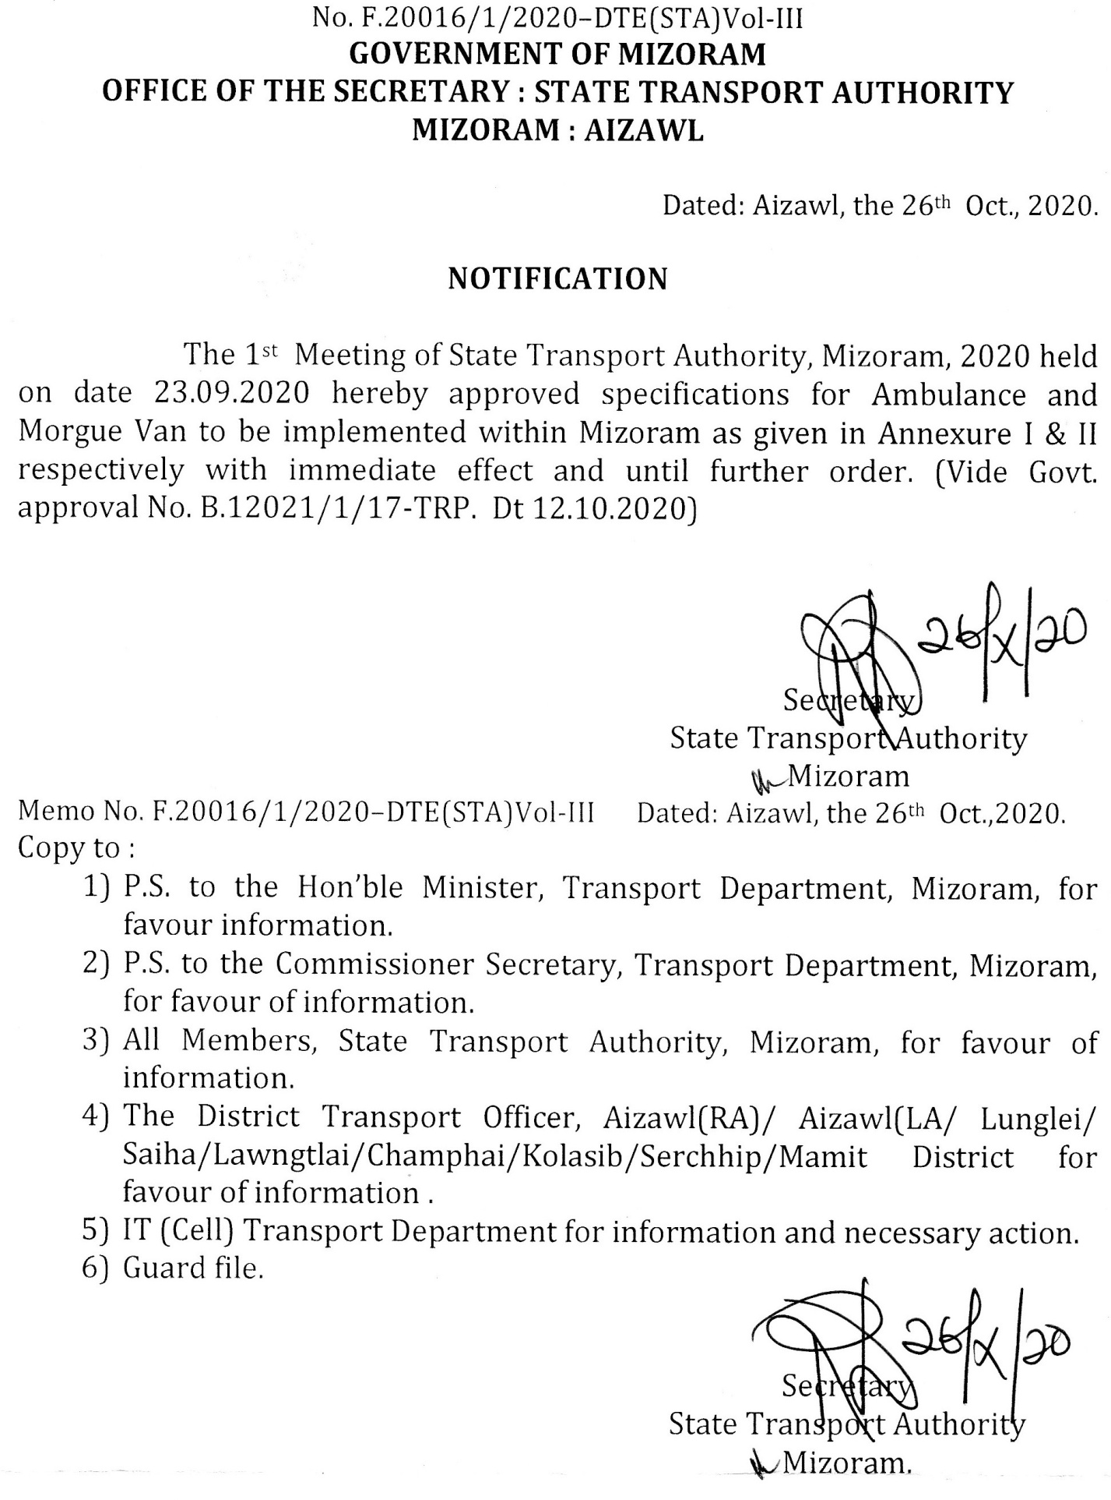

ANNEXURE - I
SPECIFICATION OF AMBULANCE
1. Damlo compartment leh Driving cabin inkarah mumal takin partition wall a awm tur a ni.
2. Stretcher a awm tur a ni.
3. Motor tlan laia damdawi leh hmanruate a tlak rem rum lohna atan a dah khawmna tur cabinet mumal tak a awm tur a ni.
4. Oxygen cylinder cage leh cylinder(ISI),flow metre(ISI), humidifier (ISI), oxygen pekna hmanrua naupang leh puitling hman tur a awm tur a ni.
5. Drip khaina tur IV hook pathum tal motor chhungah a awm tur a ni.
6. Damlo bulah a enkawltu turte thutna a awm tur a ni.
7 Motor-ah Unique High Intensity Siren leh Revolving Flashers vuah ngei tur a ni.
8. Motor hnung lam, hma lam leh a bangah AMBULANCE tih awlsam taka chhiar theih tura ziah tur a ni.
9. Motor-ah air conditioner a awm lo a nih chuan electric fan vuah ngei tur a ni.
10. Damlo awmna pindan tukverh(Glass) chanve hnuai lam chu eng lut tlang thei lo (Tinted) glass a ni tur a ni.

ANNEXURE - II
SPECIFICATION OF MORGUE VAN
1. Kuang dahna tur mumal taka siam tur a ni a. Motor a tlan zawng pawhin a tawlh sawn lohna atan a tihbehna a awm tur a ni.
2. Kuang dahna bulah thutna dah a nih chuan mumal takin siam tur a ni.
3 Kuang dahna Compartment hi a chung zar hul tur a ni.

